Portfolio Website

# Introduction

I had a larger idea that would span all 4 courses, but I think I’m going to save it for the final courses once I can hook it up to a database instead. So I decided to update my portfolio site with a basic layout and some bootstrap + react in this course. A portfolio site is a good way for recruiters to get samples of my work and get in touch with me for future projects.

# User Interface Design and Prototype

The main idea for the site is to have a plain color bar on the left side with navigation elements to the core sections on the page. All of the pictures below will be one long scrolling body of content.

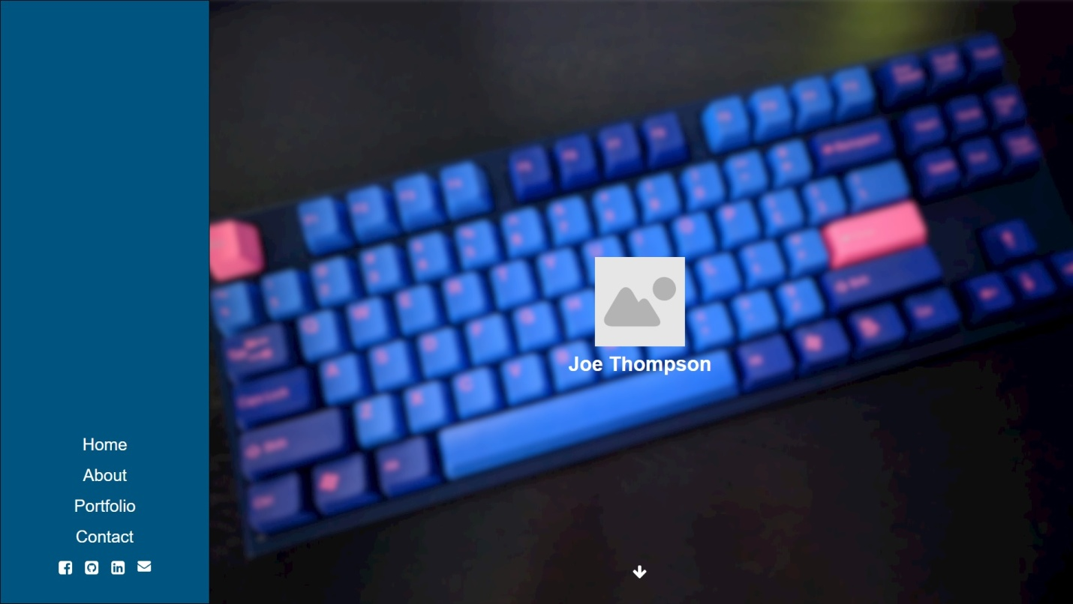

The home page will have a large background image, an image of myself, and my name. A simple and clean layout with some sort of symbol/down arrow to indicate that the user should scroll down for more info.

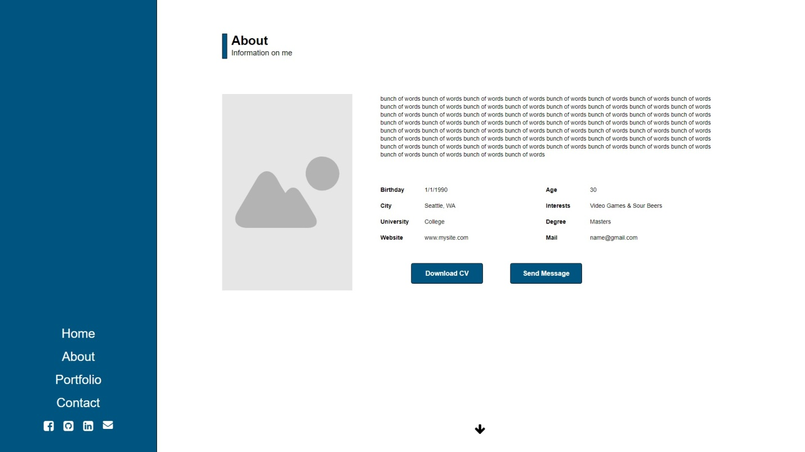

The next section is the about section where I’ll include another picture, some text about myself, and some information about myself. The link to download CV will download my resume and the send message button will link to the “contact” section.

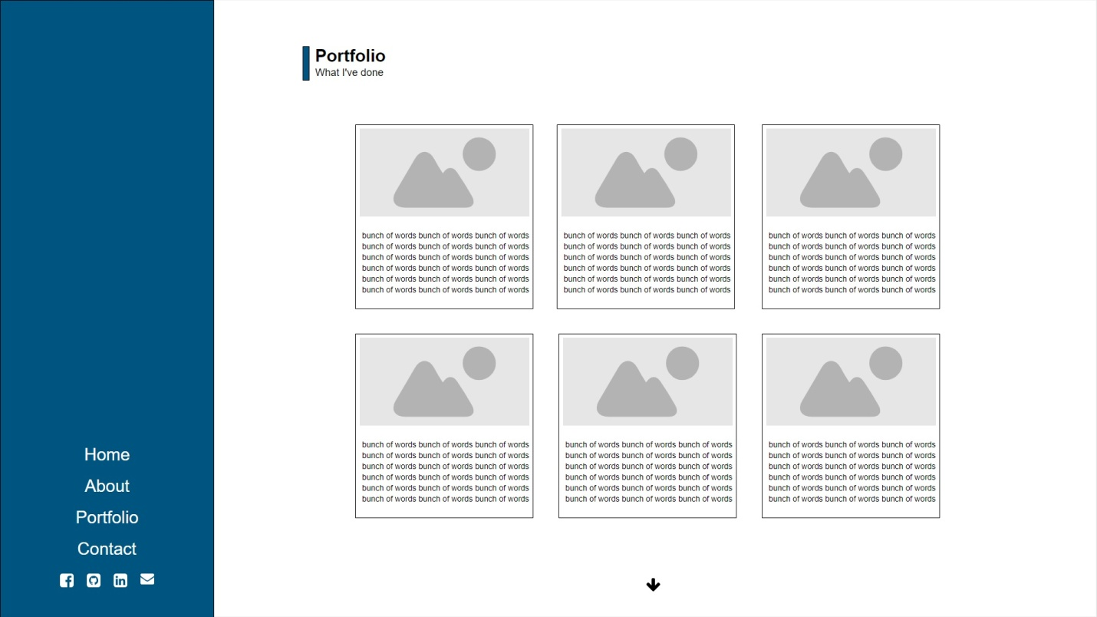

For the portfolio I’ll use a list of cards with images and text. I’m hoping these can be different heights with grid layouts so they’ll create more of a puzzle than the very structured example I have above.

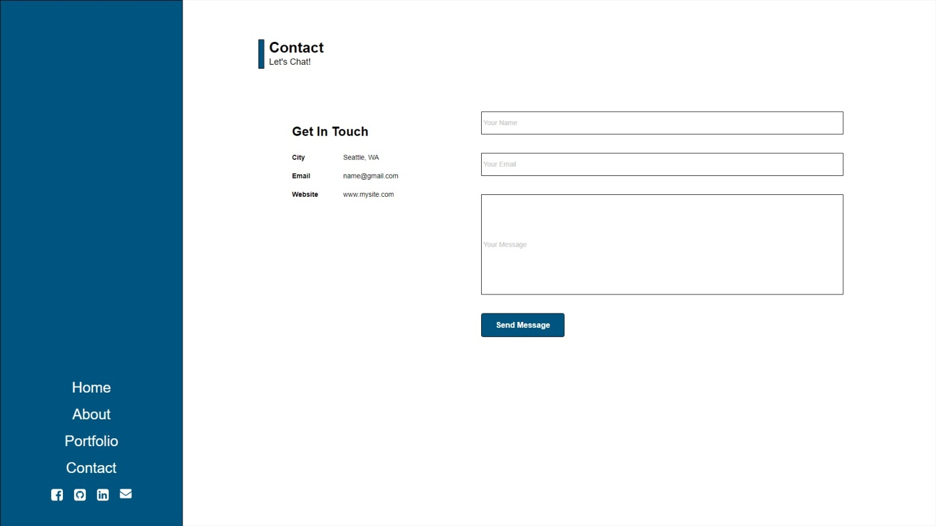

At the bottom of the scrolling page is the contact section, basic input for name, email, and message with a send message button. I’ll remind the reader about my contact information in case they want to reach out to me in a different way.

# Navigation Structure

The navigation is extremely simple for this webpage. The left bar will always be present with links to home, about, portfolio, and contact. These will perform an animated scrolling of the page to the section selected. If the user decides to scroll, there’s a send message button to skip over the portfolio section and transition down to the contact section quickly. If the user is there to browse, they can simply scroll down through the cards in the portfolio section to see examples of my work.

# References

Got some inspiration from these sites:

<https://www.florianwacker.de/>

<https://roomfive.net/andrew-couldwell/>

<http://clapat.ro/themes/satelite/>